Simulation of heat conduction in a laminar structure

Particle detectors such as the ATLAS SCT module or the CALICE slab are often laminar structures built up from sensor elements and thermal/mechanical support elements glued together. The in-plane (X,Y) dimensions of the objects are typically at least 10 cm, while the glue layer thickness (Z) is of order 0.1 mm. A full 3D mesh of such an object has to contain of order 1 million nodes. Building and solving an FEA model on such a mesh is slow. We explain how one can solve the problem by using a set of linked differential equations in 2 dimensions. This approximation works well in the usual situation where one has layers of relatively high conductivity material separated by thin layers of poorly conducting material such as glue or air.

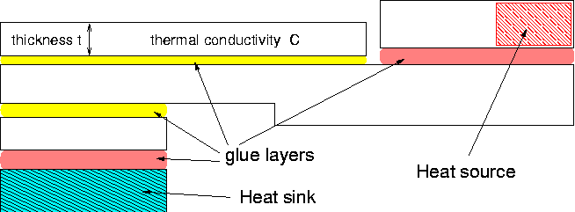

Figure 1. Example of a laminar structure. Vertical scale exaggerated.

Figure 1 shows an example of a laminar structure. The first step is to divide it up into a number of layers, which will each have their own 2D temperature field. The layers should correspond as far as possible to the materials with good conductivity. All layers will cover the whole 2D area, so if one component does not really cover the whole area the remainder of the area should be assigned the properties of air, or some other low conductivity default. Each layer will have its own temperature field, which one should think of as corresponding to the temperature in the middle of the layer thickness.

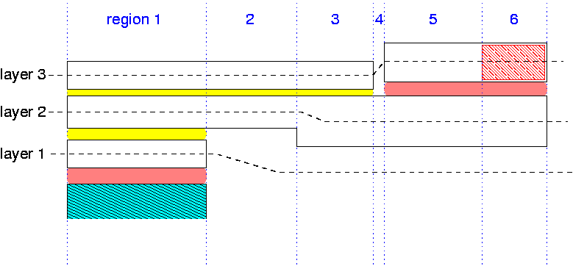

Figure 2. Division of the structure into layers and regions.

The next step is to divide the 2D view of the object up into regions, where a region is chosen so that it has uniform properties in all layers (Figure 2). For each region we compute the 2D thermal conductivity, K, within the layers and the heat transfer coefficient H between the layers:
For layer i; Ki =Ci × ti (W K⁻¹) and between i and j Hij = Cij / tij (W m⁻² K⁻¹).
If there is a heat source within the layer we compute its surface power density Si (W m⁻²) and if there is heat exchange with a fixed temperature surface outside the model we can calculate a term Ho = Co / to.
Now in the case of the model shown in Figure 1, the equations to be solved are:

K₁ ( ∂²T₁/∂x² + ∂²T₁/∂y² ) + H₁₂ (T₂ – T₁) – Ho (T₁ – T₀) = 0

K₂ ( ∂²T₂/∂x² + ∂²T₂/∂y² ) – H₁₂ (T₂ – T₁) + H₂₃ (T₃ – T₂) = 0

K₃ ( ∂²T₃/∂x² + ∂²T₃/∂y² ) – H₂₃ (T₃ – T₂) + S₃ = 0

These equations can easily be coded in FlexPDE. It is possible to introduce refinements such as different K values for the x and y directions, or making some of the H or S parameters depend on temperature, in which case the problem becomes non-linear and slower to solve.

If the object does not consist of alternating layers of high and low thermal conductivity, one can improve the approximation by modifying K to take into account the in-plane conductivity of half of each neighbouring ‘low C’ layers;
Ki =Ci × ti + Cij × tij /2 + Chi × thi /2
and similarly one can modify H to include the thermal resistance of half the ‘high C’ layer thickness;
Hij = H₁ H₂ /(H₁ + H₂) where H₁ = Cij / tij and H₂ = 2 Ci / ti .

