Magnetic field calculations for the TESLA spectrometer main magnet by the 3D MAFIA code

N.A.Morozov
DESY, Zeuthen, August 2003
(internal report)

Preliminary magnetic field calculations have been provided for the TESLA spectrometer main magnet by 2D computer program POISSON SUPERFISH. Those calculations gave the principal decision for the main magnet design. For the 3D effects including into this procedure the magnetic field calculations were realized by 3D electromagnetic simulation code MAFIA.
For the static magnetic field calculations three MAFIA modules were used:
- M – the mesh generator.
- S – the static solver.
- P – the post processor.

Mesh generator

The mesh generation for the main magnet 3D model was realized with 300000 meshpoints. Because of the magnet symmetry it was generated for the ¼ magnet part. The minimal value for the meshsize for this model was achieved about 1 - 2 cm. The exitation coils in the MAFIA code are defining by the filaments. The magnet coil was simulated by 12 filaments (2 vertical layers × 6 filaments). The filaments have the rectangular shape in the plane view. The 3D and 2D views of the model are presented in the Fig.1 – 3.

Solver

For the magnet solver simulation it was used the same iron magnetization table as in case of 2D POISSON SUPERFISH code. The required maximal magnet gap field was achieved for the same current of the coil excitation as in 2D simulation. The required CP time (PARIS or Solar cluster) for the getting the solution for this model is equal to 20 min.
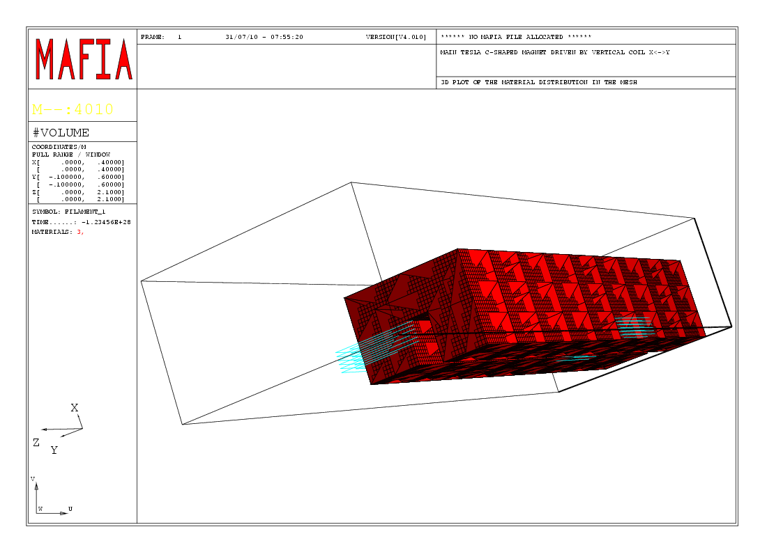
Fig.1. 3D view of the main spectrometer magnet model with iron yoke and filaments which represent the coil
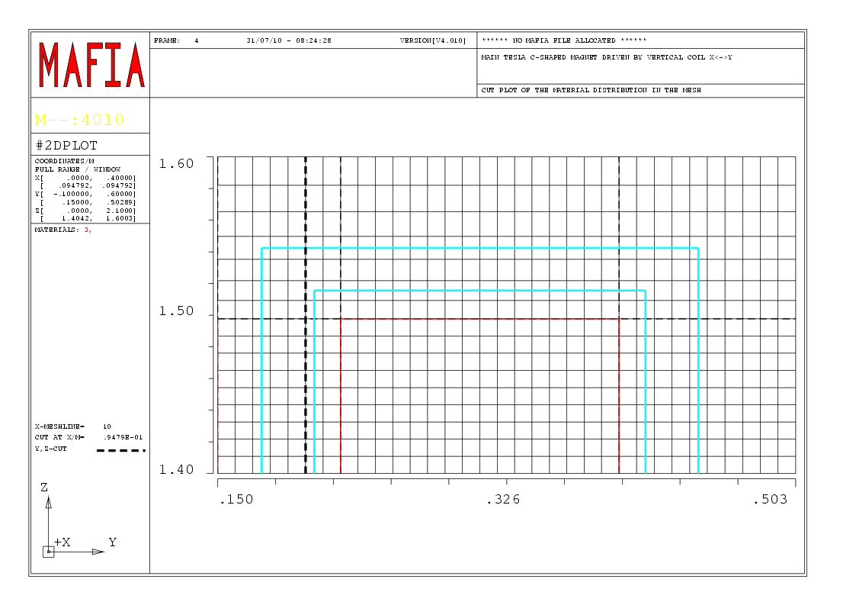
Fig.2. 2D view of the magnet model with the grid in the median magnet plane (top view) showing the end part of the pole with the filaments
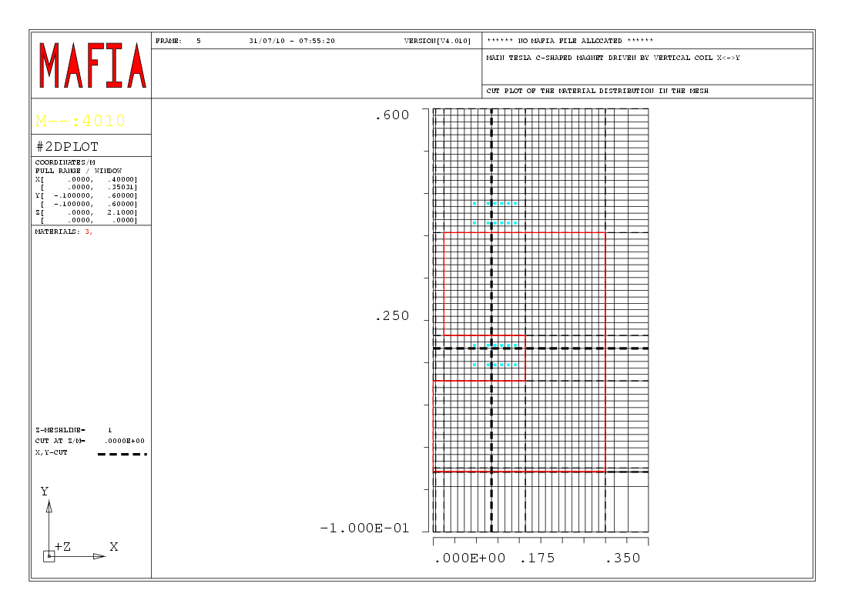
Fig.3. 2D view of the magnet model with the grid in the magnet middle transverse cross-section

Post processor

Some post processor views presenting the overall impression from the 3D picture for the main magnet field are shown in the Fig.4 – 17 (for the maximal and minimal magnetic field B_{gap}=0.44, 0.05 T).

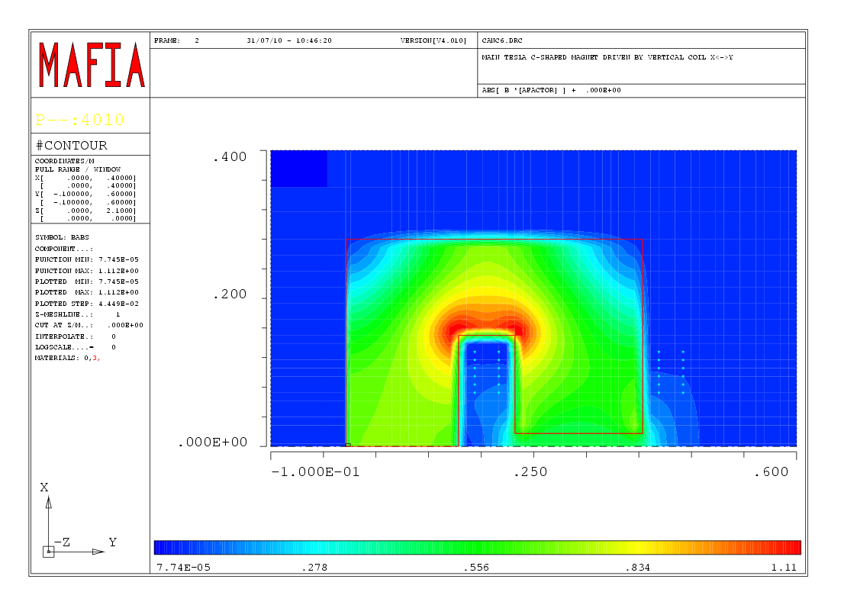
Fig.4. Magnetic field contour plot (middle cross-section, Z=0), (B=0.44 T)
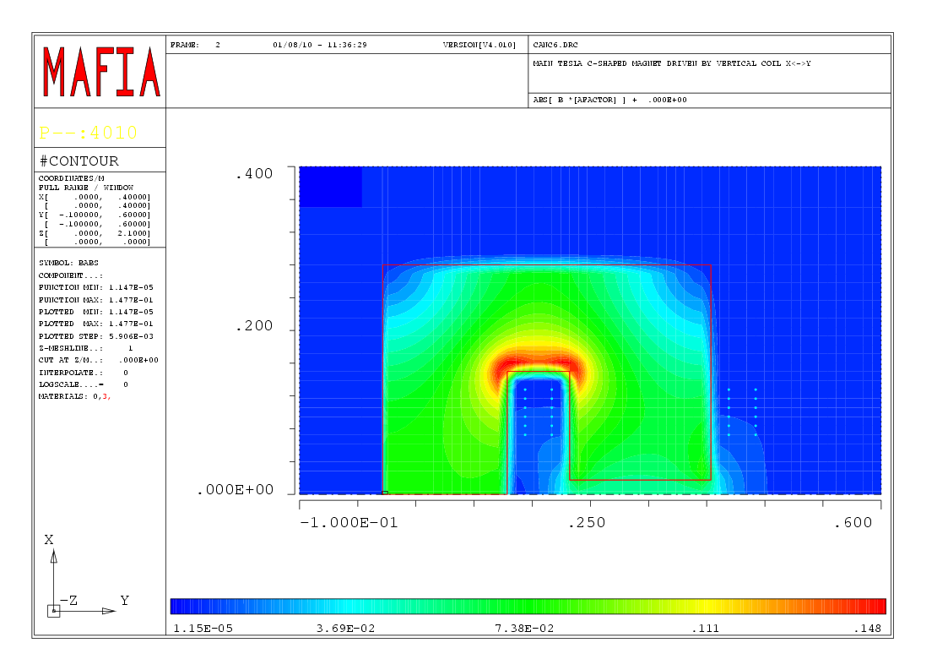
Fig.5. Magnetic field contour plot (middle cross-section, Z=0), (B=0.05 T)

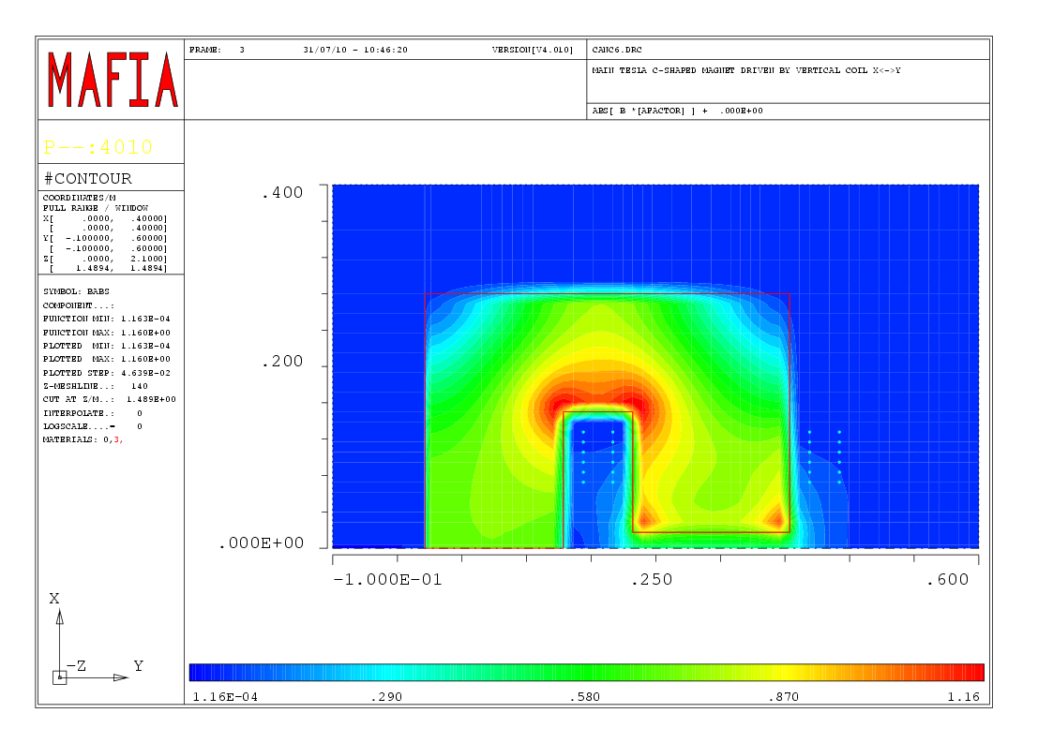
Fig.6. Magnetic field contour plot (cross-section near the pole edge, Z=148 cm) (B=0.44 T)
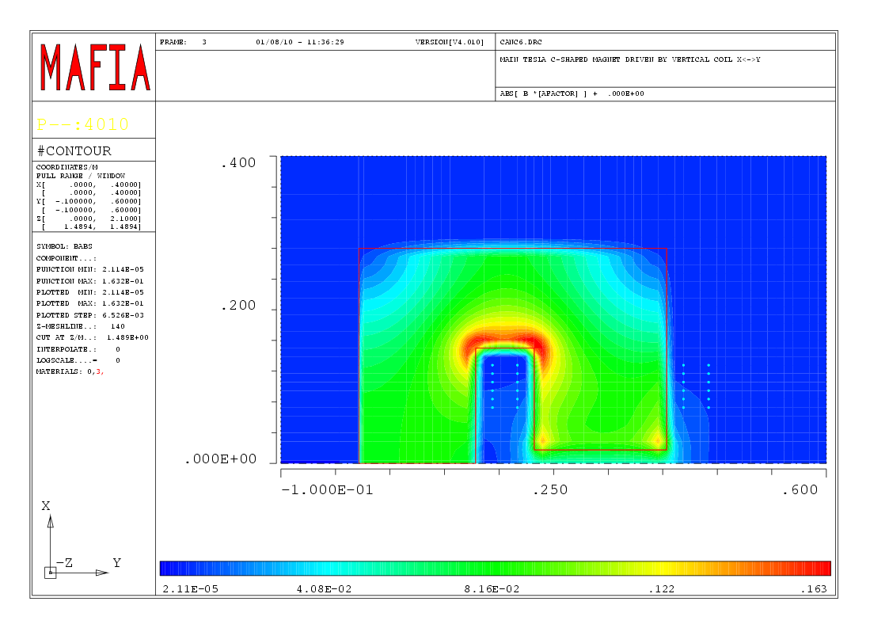
Fig.7. Magnetic field contour plot (cross-section near the pole edge, Z=148 cm) (B=0.05 T)
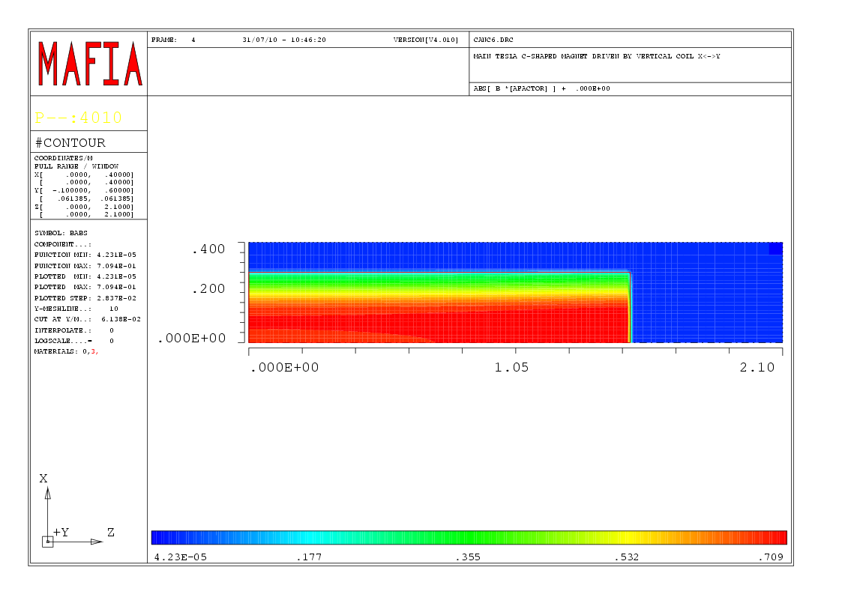
Fig.8. Magnetic field contour plot (vertical cross-section throw the middle point of the vertical yoke, X=6.1 cm) (B=0.44 T)
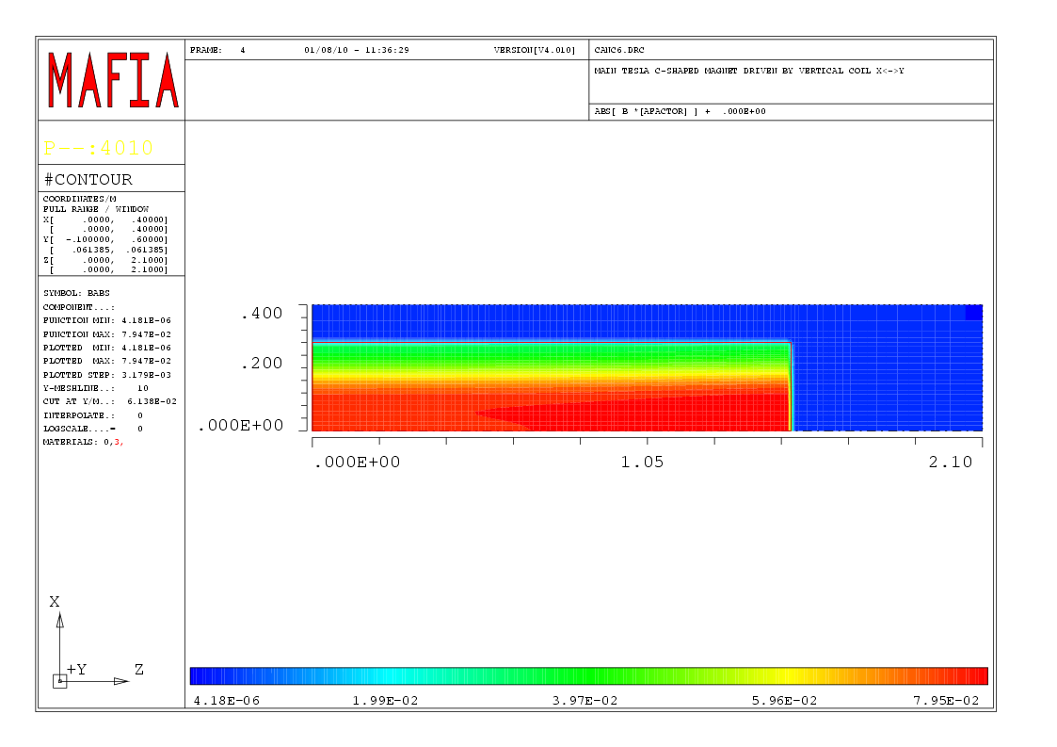
Fig.9. Magnetic field contour plot (vertical cross-section throw the middle point of the vertical yoke, X=6.1 cm) (B=0.05 T)

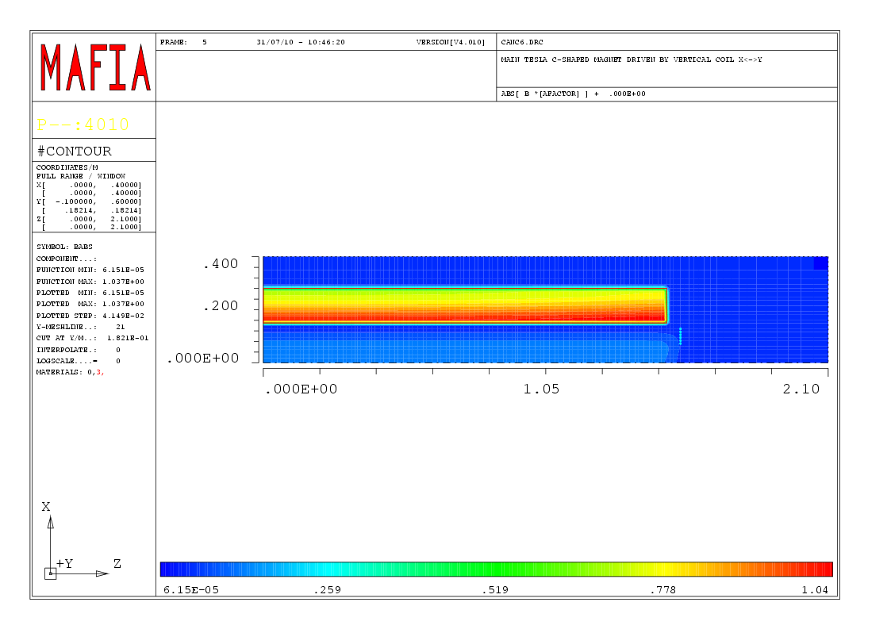
Fig.10. Magnetic field contour plot (vertical cross-section throw the middle point of the horizontal yoke, X=18.2 cm) (B=0.44 T)
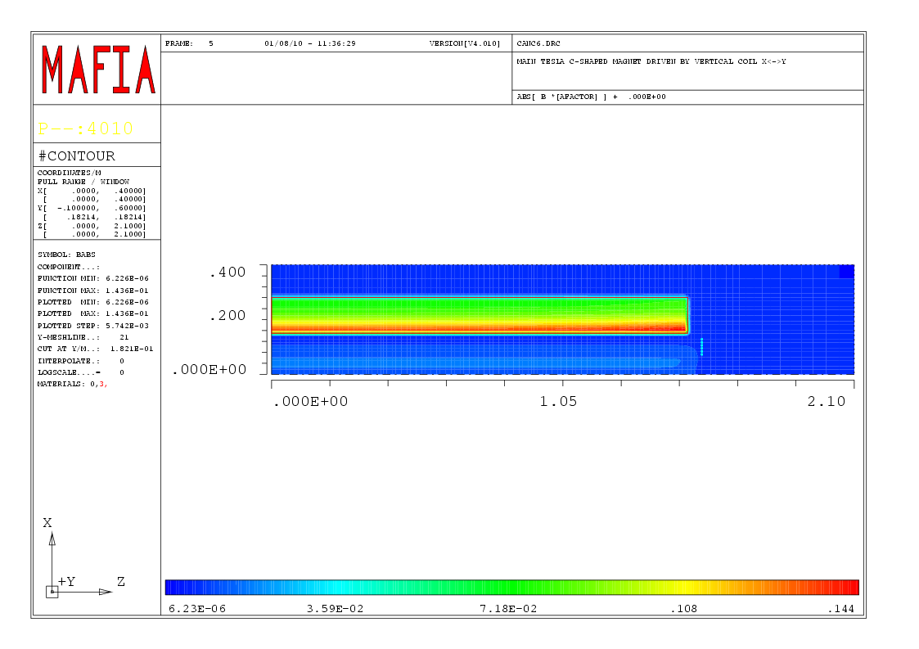
Fig.11. Magnetic field contour plot (vertical cross-section throw the middle point of the horizontal yoke, X=18.2 cm) (B=0.05 T)

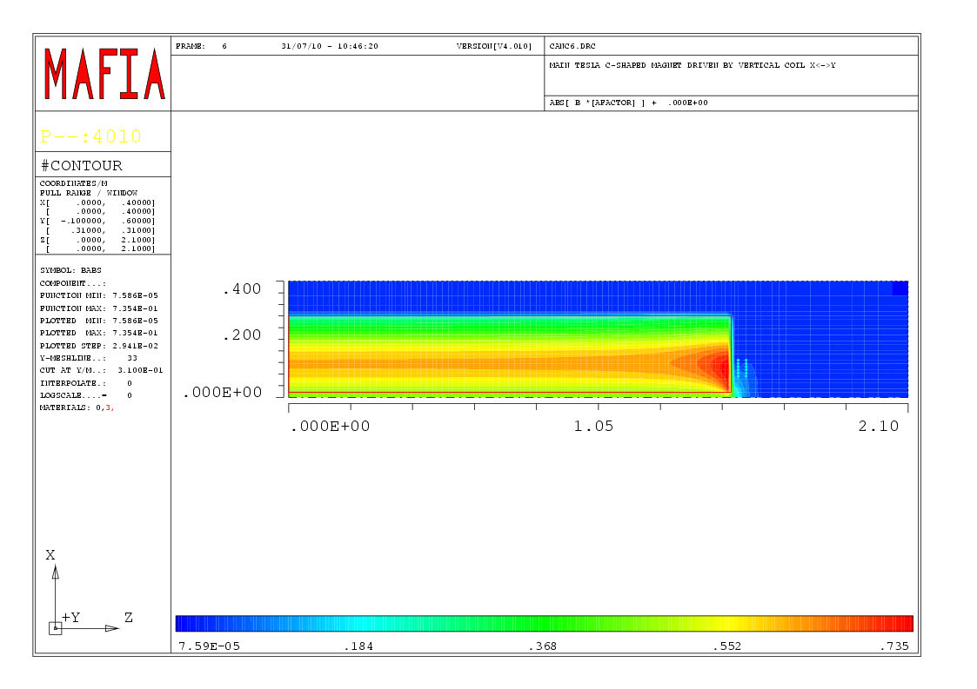
Fig.12. Magnetic field contour plot (vertical cross-section throw the middle point of the pole, X=31 cm) (B=0.44 T)
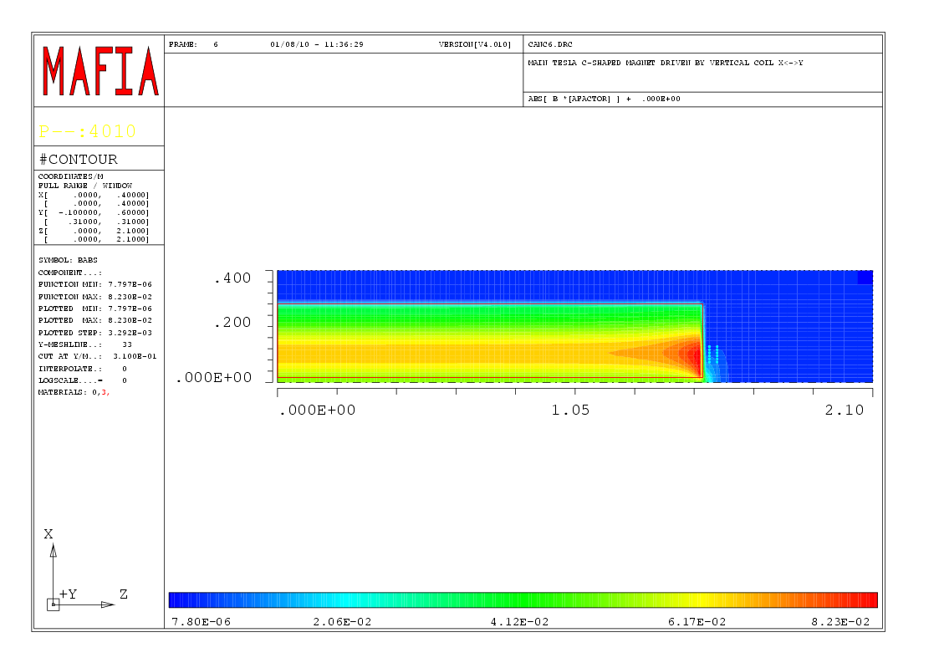
Fig.13. Magnetic field contour plot (vertical cross-section throw the middle point of the pole, X=31 cm) (B=0.05 T)

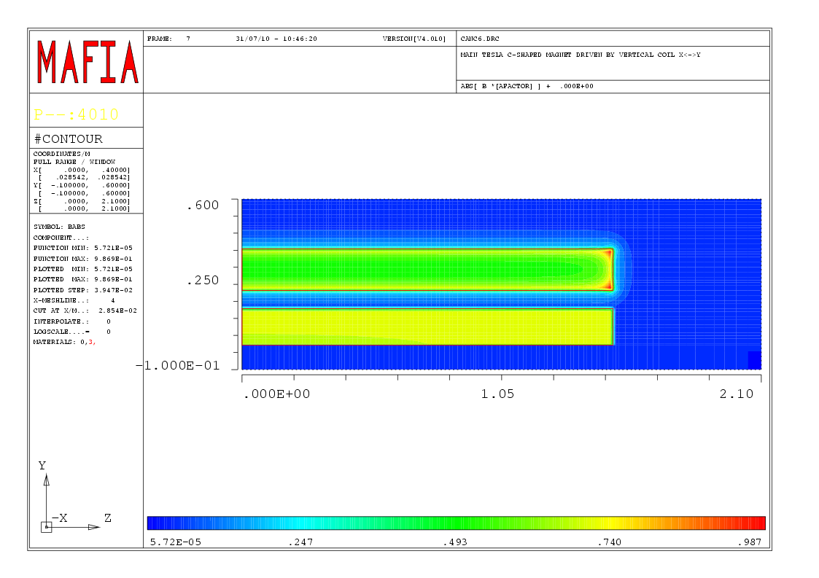
Fig.14. Magnetic field contour plot (horizontal cross-section, Y=2.8 cm) (B=0.44 T)
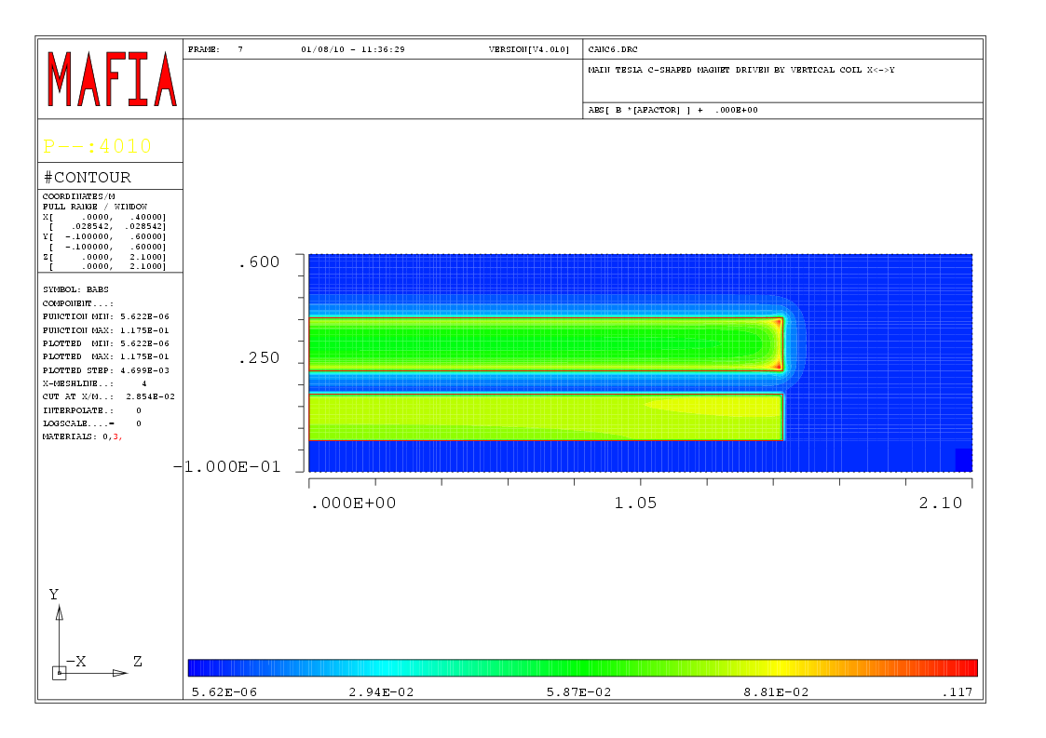
Fig.15. Magnetic field contour plot (horizontal cross-section, Y=2.8 cm) (B=0.05 T)

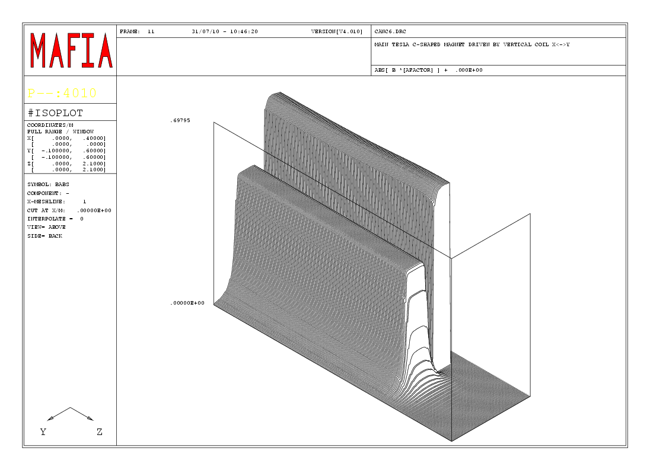
Fig.16. Isoplot view of the magnetic field in the median magnet plane (B=0.44 T)
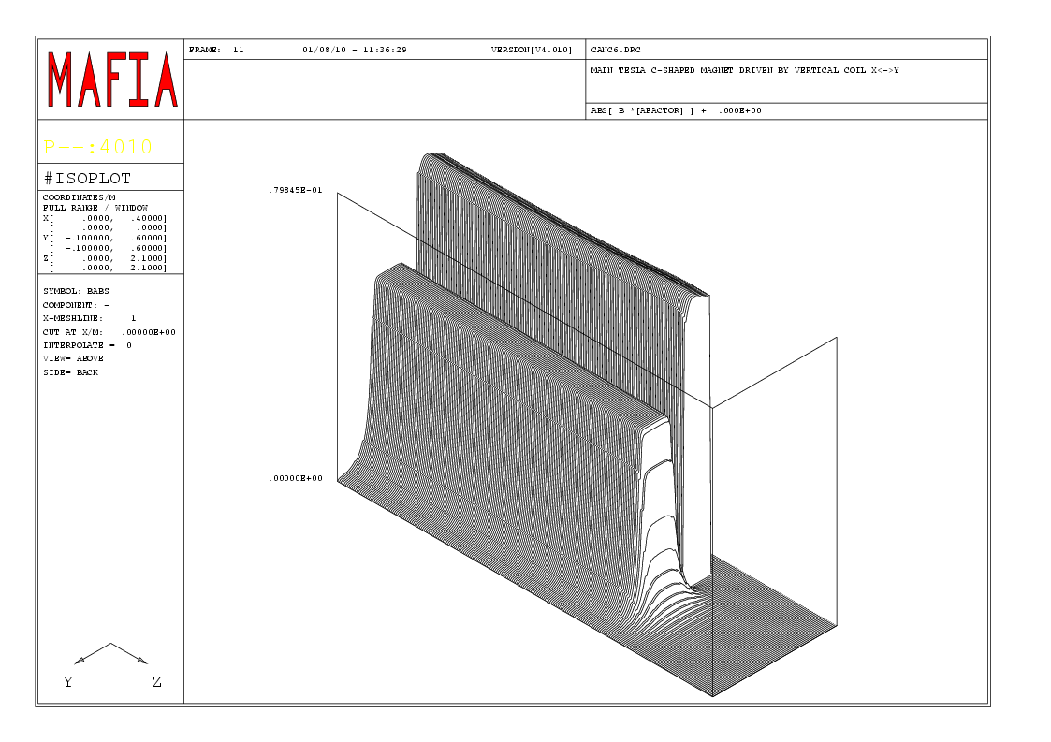
Fig.17. Isoplot view of the magnetic field in the median magnet plane (B=0.05 T)

Fig.18. Normalized magnetic field in the middle cross-section of the main magnet
Fig.19. Normalized magnetic field in the middle cross-section of the main magnet for 2D and 3D models (B=0.44 T)

In the Fig.18 the normalized magnetic field for the middle magnet transverse cross-section is presented. The 3D magnetic field simulation shows that the field distribution is very closed to the 2D one (Fig.19). It means that only for the magnet length of 3 m the 2D simulation (it assumes that in the longitudinal direction the magnet is infinitely long) is closed to the reality. In the Fig.20 the normalized dependence of the magnetic field in longitudinal direction is presented. The magnetic field influence of the 3D effects is possible to see from the Fig.21.
Fig.20. Normalized magnetic field along the beam line
Fig.21. Longitudinal magnetic field integral (normalized)

Fig.22. Normalized magnetic field in the middle cross-section of the main magnet

Fig.23. Longitudinal magnetic field integral (normalized)

The uniformity region (magnetic field integral) is equal to 13 mm in case of use of 3 reference beam energies for it’s calculation. If to use the energies covering the whole spectrometer working region (Fig.22-23), the uniformity region is decreasing to 11 mm.

Conclusions

- The main spectrometer magnet was simulated by 3D MAFIA code.
- In the magnet middle cross-section the field uniformity region is very closed to 2D simulation one.
3. Because of the 3D effects the uniformity region for the longitudinal magnetic field integral is shifted on about 15 mm (from the one in the middle cross-section). This effect has to be taken into account in the magnet design. The width of the uniformity region is equal to 13 mm.

